**Name:** Ahmed Ayman Elsayed Mohammed

**B.N:** 28

**Date:**

**Topic:** Artificial Intelligent

**Application Brief:**

What Is Artificial Intelligence (AI)?

Artificial intelligence (AI) refers to the simulation of human intelligence in machines that are programmed to think like humans and mimic their actions. The term may also be applied to any machine that exhibits traits associated with a human mind such as learning and problem-solving.

The ideal characteristic of artificial intelligence is its ability to rationalize and take actions that have the best chance of achieving a specific goal.

Understanding Artificial Intelligence

When most people hear the term artificial intelligence, the first thing they usually think of is robots. That's because big-budget films and novels weave stories about human-like machines that wreak havoc on Earth. But nothing could be further from the truth.

Artificial intelligence is based on the principle that human intelligence can be defined in a way that a machine can easily mimic it and execute tasks, from the most simple to those that are even more complex. The goals of artificial intelligence include learning, reasoning, and perception.

As technology advances, previous benchmarks that defined artificial intelligence become outdated. For example, machines that calculate basic functions or recognize text through optimal character recognition are no longer considered to embody artificial intelligence, since this function is now taken for granted as an inherent computer function.

AI is continuously evolving to benefit many different industries. Machines are wired using a cross-disciplinary approach based in mathematics, computer science, linguistics, psychology, and more.

Applications of Artificial Intelligence

The applications for artificial intelligence are endless. The technology can be applied to many different sectors and industries. AI is being tested and used in the healthcare industry for dosing drugs and different treatment in patients, and for surgical procedures in the operating room.

Other examples of machines with artificial intelligence include computers that play chess and self-driving cars. Each of these machines must weigh the consequences of any action they take, as each action will impact the end result. In chess, the end result is winning the game. For self-driving cars, the computer system must account for all external data and compute it to act in a way that prevents a collision.

Artificial intelligence also has applications in the financial industry, where it is used to detect and flag activity in banking and finance such as unusual debit card usage and large account deposits—all of which help a bank's fraud department. Applications for AI are also being used to help streamline and make trading easier. This is done by making supply, demand, and pricing of securities easier to estimate.

Categorization of Artificial Intelligence

Artificial intelligence can be divided into two different categories: weak and strong. Weak artificial intelligence embodies a system designed to carry out one particular job. Weak AI systems include video games such as the chess example from above and personal assistants such as Amazon's Alexa and Apple's Siri. You ask the assistant a question, it answers it for you.

Strong artificial intelligence systems are systems that carry on the tasks considered to be human-like. These tend to be more complex and complicated systems. They are programmed to handle situations in which they may be required to problem solve without having a person intervene. These kinds of systems can be found in applications like self-driving cars or in hospital operating rooms.

Special Considerations

Since its beginning, artificial intelligence has come under scrutiny from scientists and the public alike. One common theme is the idea that machines will become so highly developed that humans will not be able to keep up and they will take off on their own, redesigning themselves at an exponential rate.

Another is that machines can hack into people's privacy and even be weaponized. Other arguments debate the ethics of artificial intelligence and whether intelligent systems such as robots should be treated with the same rights as humans.

Self-driving cars have been fairly controversial as their machines tend to be designed for the lowest possible risk and the least casualties. If presented with a scenario of colliding with one person or another at the same time, these cars would calculate the option that would cause the least amount of damage.

Another contentious issue many people have with artificial intelligence is how it may affect human employment. With many industries looking to automate certain jobs through the use of intelligent machinery, there is a concern that people would be pushed out of the workforce. Self-driving cars may remove the need for taxis and car-share programs, while manufacturers may easily replace human labor with machines, making people's skills more obsolete.

**Screenshots:**

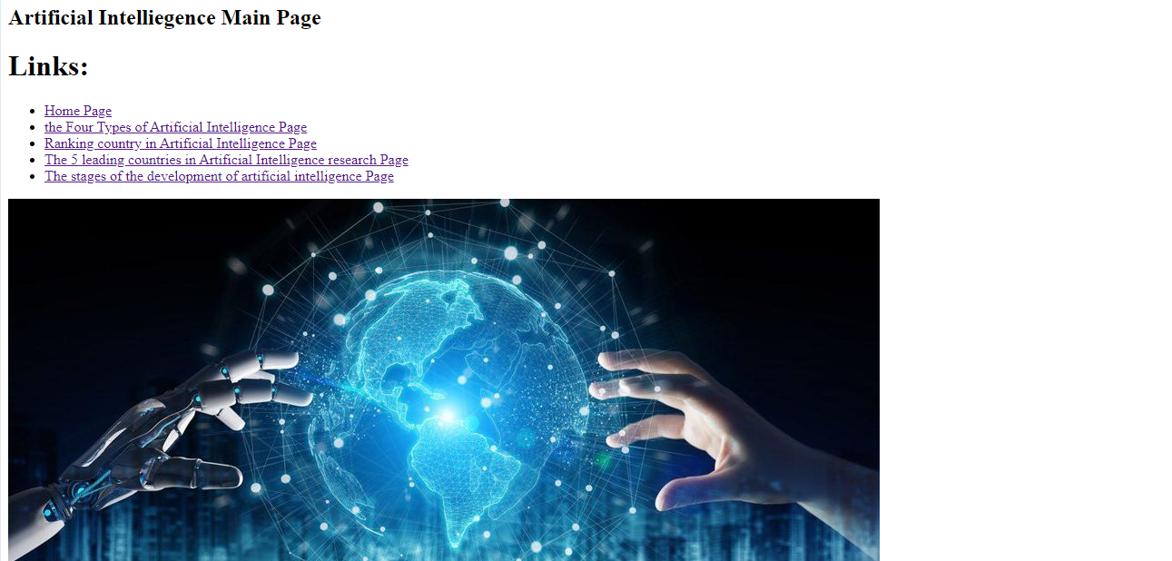

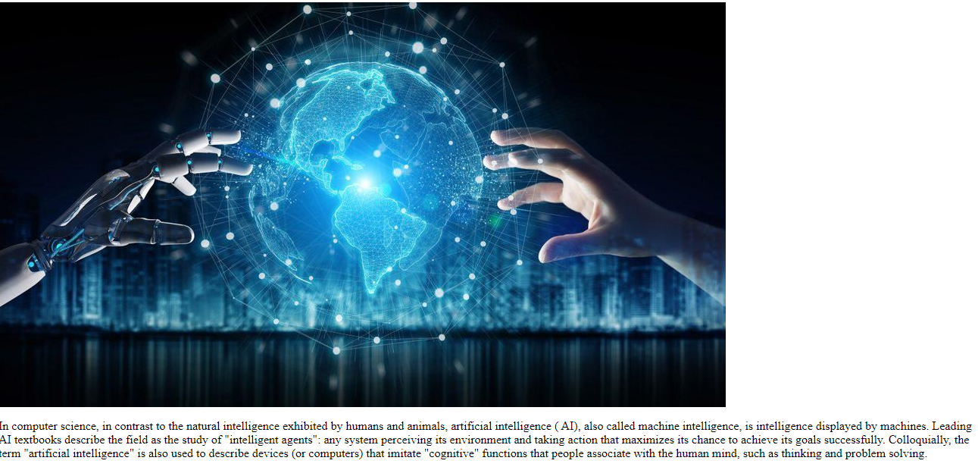

**Source Code:**

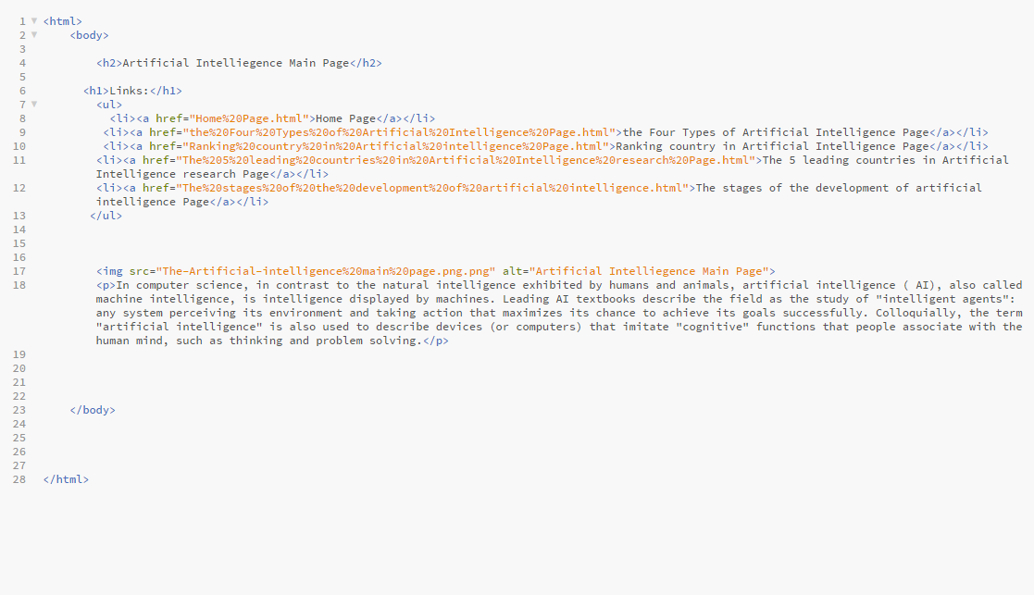

**-----------------------**

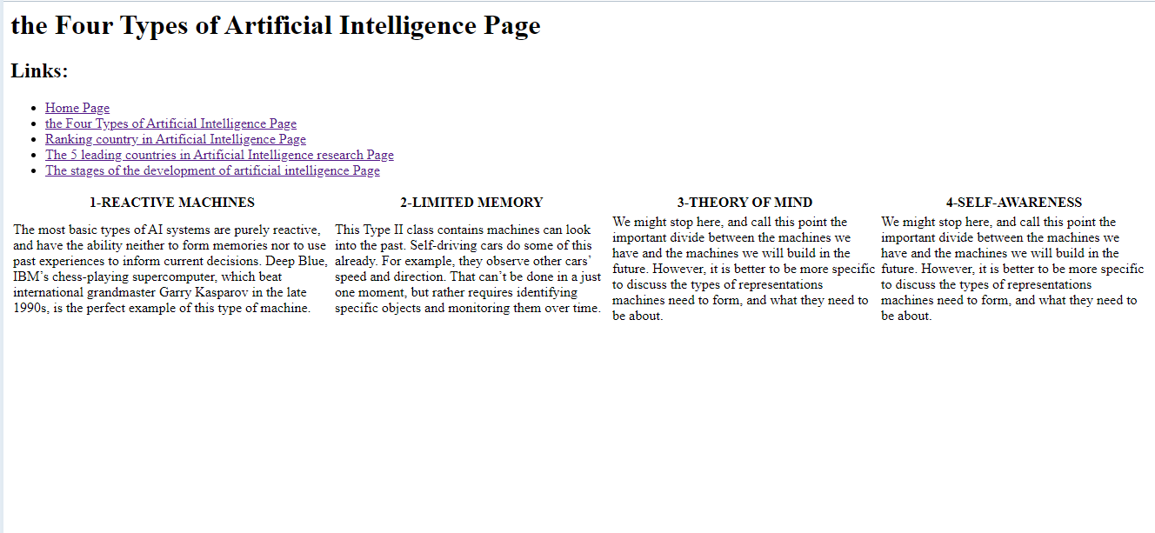

**Source Code:**

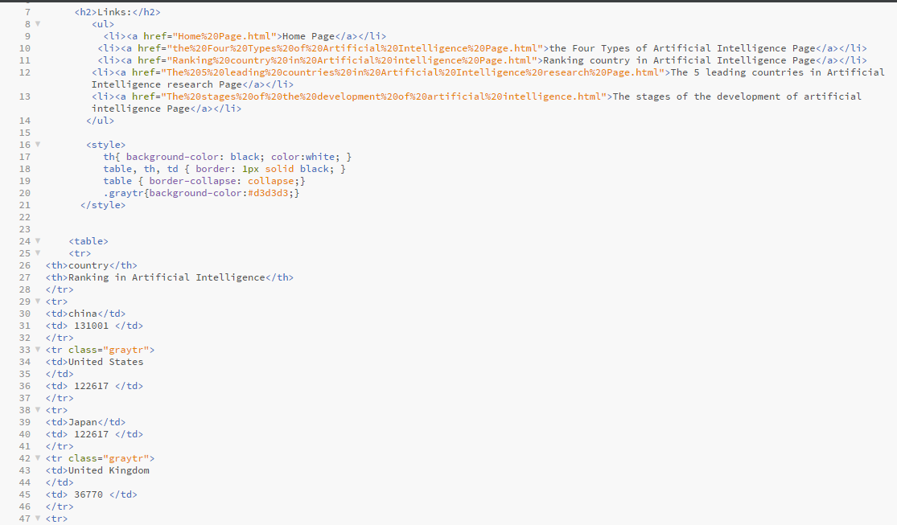



**-------------------------**

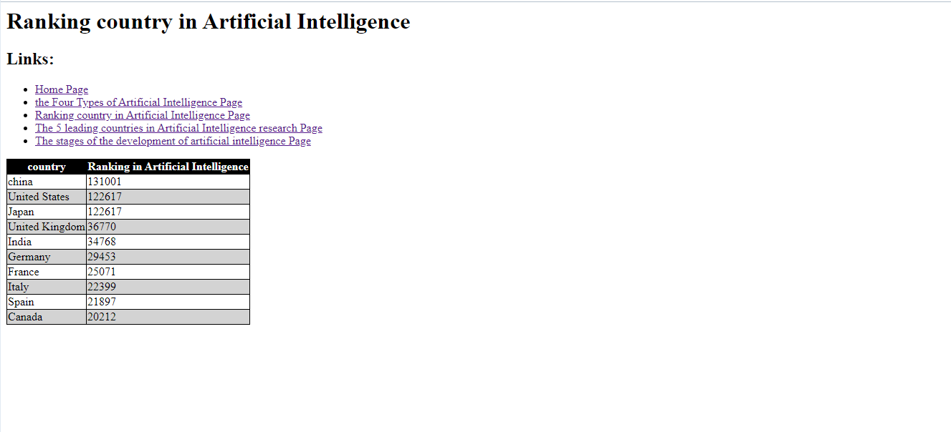

**Source Code:**

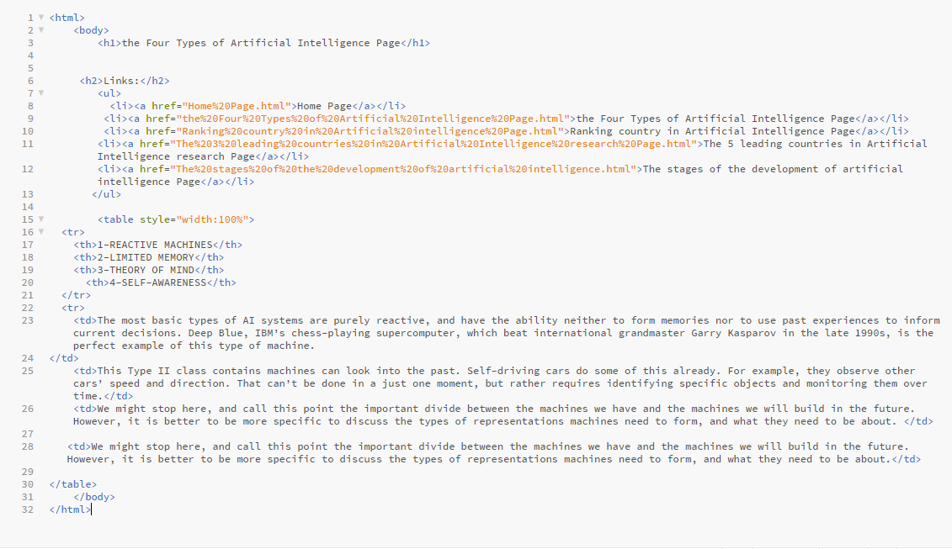

**---------------------------**

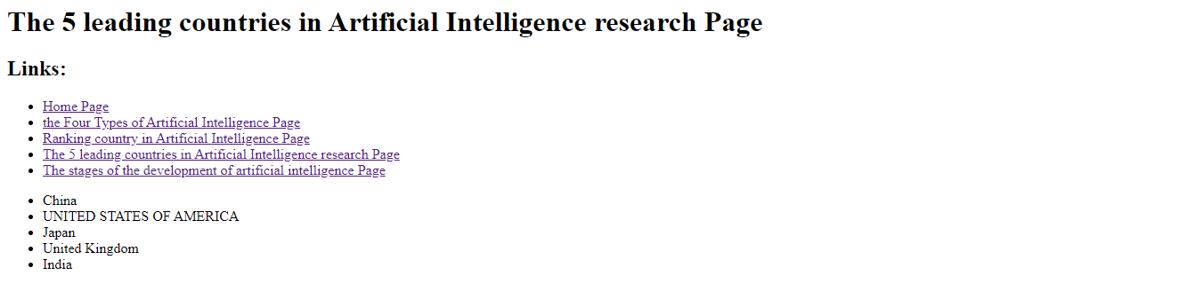

**Source Code:**

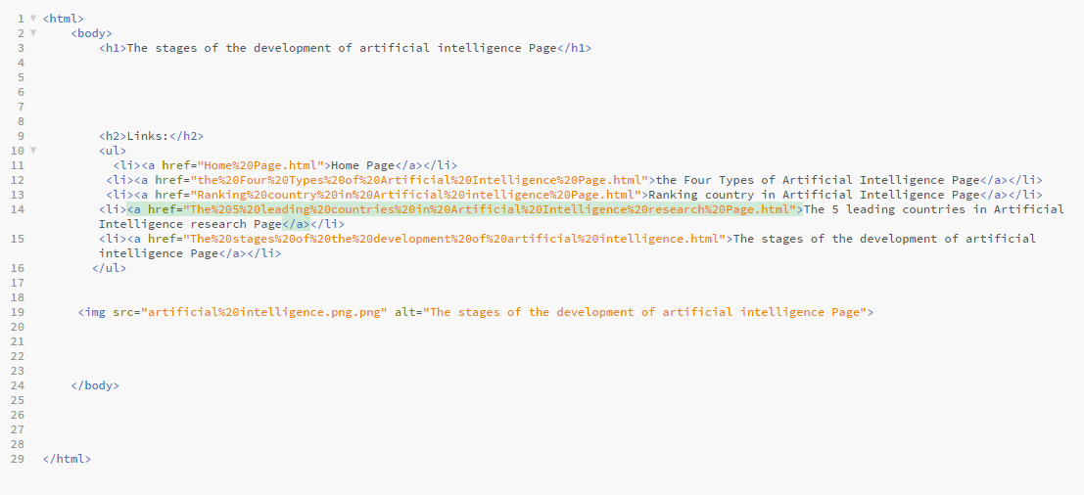

**-------------------------------**

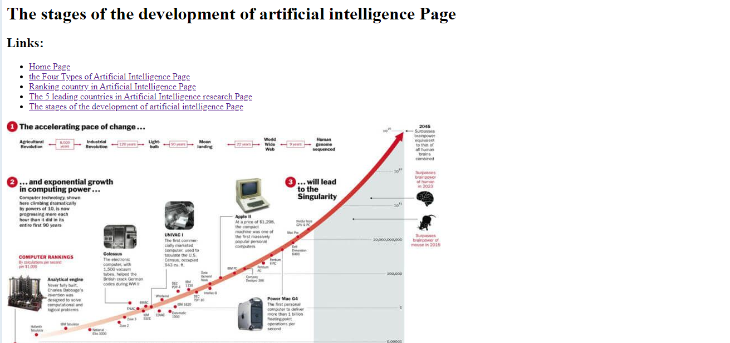

**Source Code:**

